Dear interested readers,
during the holidays between the years 2021 and 2022, we developed or better, finished the learning modules of IO2. In total we created six modules to explain the needs of entrepreneurship and starting a business.
The titles of the modules are as follows:
- Module 1: Finding the right Idea and shaping it into an Opportunity
  - Understand the basics of planning the new business idea, how to plan and think critically (realistically)
- Module 2: Forms of Entrepreneurships
- Module 3: Realistic Planning and Business Models
  - Planning the business idea - developing a BUSINESS PLAN or creating a BUSINESS CANVAS, choosing the right BUSINESS MODEL
- Module 4: Basics of Marketing and Branding
  - Basics of MARKETING and BRANDING (incl. name of the business idea)
- Module 5: Basics of Financing Planning
- Module 6: Common Mistakes and learning from failures
  - Common MISTAKES that can be avoided already in the start.
The following link shows you the implementation of the content in prototypes:
https://www.art-smart.eu/familybusinesslibrary

Additional to the learning modules the consortium created mentoring and coaching modules for the Start- up entrepreneurs. To demonstrate the working process of the partners, the consortium used the working platform miro, to brainstorm ideas, contents and solutions for the modules. In the next days, we will spread the links of the coaching and mentoring links here, too.

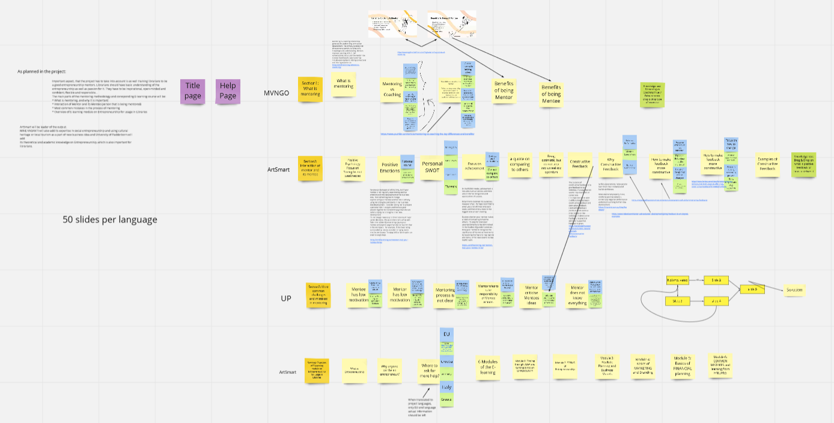
Figure 1 Screenshot of the working process in miro (Link to miro: https://miro.com/app/board/o9J_lsmJyyk=/ ).

Form the screenshot you see, that there is a huge working process according to mentoring and coaching of Family Business Library. The main contents which should be part of the modules deals with
- the idea of mentoring
- the idea of coaching
  - the similarities and differences)
- Motivation of mentees and the mentors
  - Constructive, positive feedback structures and ideas
- What is entrepreneur?
  - Overview and hints to the modules 1 to 6

All further information, links to the modules and additional materials of the project are available under downloads as Open Educational Resources (see tab or go to the link: https://family-business-library.eduproject.eu/?page_id=21 ).

At least, we are working on the Intellectual Outcome 3 – the Family Business Library Policy Paper. One main part of the paper will be to explain improvements for future learning platforms for start up entrepreneurs. Therefore, we would like to ask you to participate the following quantitative questionnaire. Please use your country language to fill in the questionnaire:

Italian: https://umfragen.uni-paderborn.de/index.php/548217?lang=de
German: https://umfragen.uni-paderborn.de/index.php/268958?lang=de
Latvia: https://umfragen.uni-paderborn.de/index.php/913964?lang=de
Greek: https://umfragen.uni-paderborn.de/index.php/631547?lang=de
Croatia: https://umfragen.uni-paderborn.de/index.php/191269?lang=de
How maintained, your opinion is of great interest to us and contributes significantly to the improvement and further development of the design of future learning platforms and educational materials for start-up founders. Your personal opinion counts when answering the questions, so there are no “right” or “wrong” answers to the assessment questions. If you are unsure about the answer to a question, please select the answer that best reflects your opinion.

All our best and a great working period
Your Family Business Team Germany!

